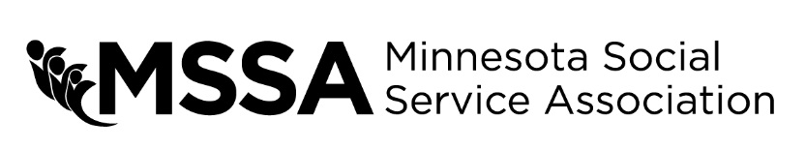
MORRIS HURSH AWARD
Each year MSSA recognizes those who have made significant contributions to the health and human service field with awards presented at the Annual Training Conference and Expo. This is your opportunity to recognize an individual or group of individuals that have done so in the past year with a nomination for the Morris Hursh award.
Name of Nominee:
Agency or Organization: Address: City/State/Zip: Phone: Email:

To complete the nomination process, please provide detailed answers to the questions below about the individual or group that you would like to recognize. If you need additional space to write, feel free to write on the back of the form or type your answers on a separate sheet.

Describe the nominee's contribution to the human service profession on a national level.

Describe the nominee’s contribution to the human service profession at the state level.

Describe the nominee's contribution to the human service profession on a local level within their community.

Describe the nature and level of the nominee's involvement in MSSA and/or other professional human service groups.

Your name: Organization:

MSSA Region:
Phone:
Email:

Signature/Date:

