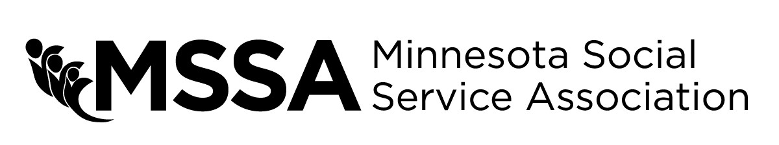

OUTSTANDING VOLUNTEER SERVICE AWARD
Each year MSSA recognizes those who have made significant contributions to the health and human service field with awards presented at the Annual Training Conference and Expo. This is your opportunity to recognize an individual who has done so in the past year with a nomination for the Outstanding Volunteer Service award.
Name of nominee: Agency or Organization: Address: City/State/Zip: Phone: Email:

To complete the nomination process, please provide detailed answers to the questions below about the individual or group that you would like to recognize. If you need additional space to write, feel free to write on the back of the form or type your answers on a separate sheet.

What volunteer position (not paid staff) does the nominee hold?

How the does the nominee consistently provide outstanding results though direct service to the community?

How has the nominee’s use of interpersonal skills and experience contributed to their service?

How has the nominee showed a sustained commitment to volunteerism? i.e., length of time, intensity of service.

Your name: Organization:

MSSA Region:
Phone:
Email:

Signature/Date:

