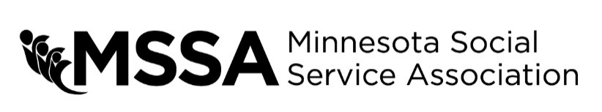
OUTSTANDING STAFF ACHIEVEMENT AWARD

Each year MSSA recognizes those who have made significant contributions to the health and human service field with awards presented at the Annual Training Conference and Expo. This is your opportunity to recognize an individual who has done so in the past year with a nomination for the Outstanding Staff Achievement award.
Name of nominee: Agency or Organization: Address: City/State/Zip: Phone: Email:

To complete the nomination process, please provide detailed answers to the questions below about the individual or group that you would like to recognize. If you need additional space to write, feel free to write on the back of the form or type your answers on a separate sheet.
Using specific examples, describe how the nominee consistently demonstrates outstanding service to clients.

Describe how the nominee is valued by the agency/coworkers for contributions to the work team.

In what ways does the nominee routinely performs tasks at an excellent level?

How has the nominee used interpersonal skills and experience to help create a positive client-focused work environment?

How has the nominee created or used community resources to effect change for clients?

How has the nominee participated in, promoted or been recognized for commitment to the field of Human Services?

Your name: Organization:

MSSA Region:
Phone:
Email:

Signature/Date:

